



Name : Hafsa Shahid
Reg no : B25F34CYS101
Program : Cybersecurity
Instructor’s name: Hassan Ali
Date Submitted : 04 / 07 / 26
Deadline : 05 / 07 / 26
Assignment Report # 1

• INTRODUCTION •
In this class we learned the basic theory of cybersecurity its domains, career paths, CIA triad, types of cyber attacks and basic security principles. At the end of the lecture, we were given a task which is as follows.

Assignments Tasks:

Task : Install Kali Linux, Install kali linux on your device via Virtual Machine or any other method.

• TASK •
Task : Install Kali Linux, install kali linux on your device via Virtual Machine or any other method.
Steps Followed:
- Install a Virtual machine sandbox (I installed VMware Workstation).
- Install the zip file for Kali linux from Google.
- Extract the zip file and open it using VMware Workstation.

• Step 1 •
Step 1 : Install a Virtual machine sandbox ( installed VMware Workstation).
Follow the basic installation steps,
- Download the installer from Google then proceed as normal.
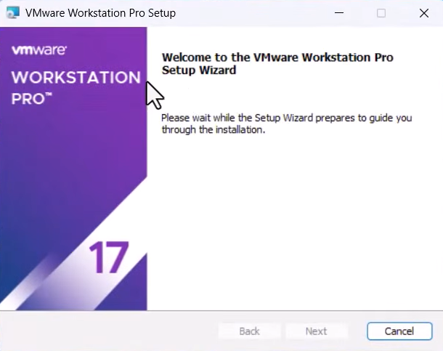

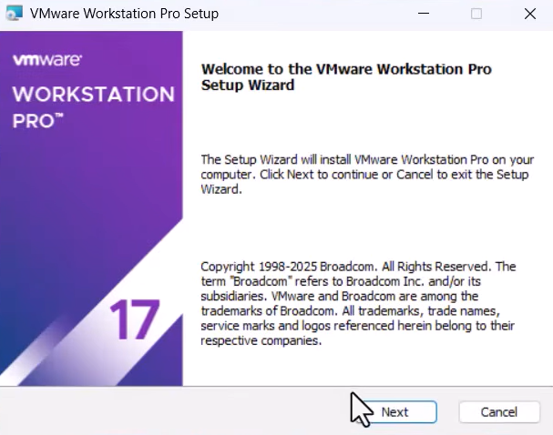

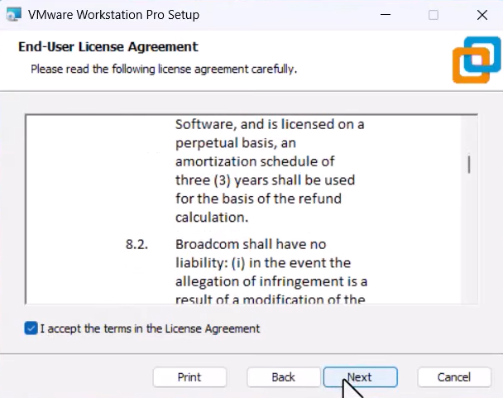

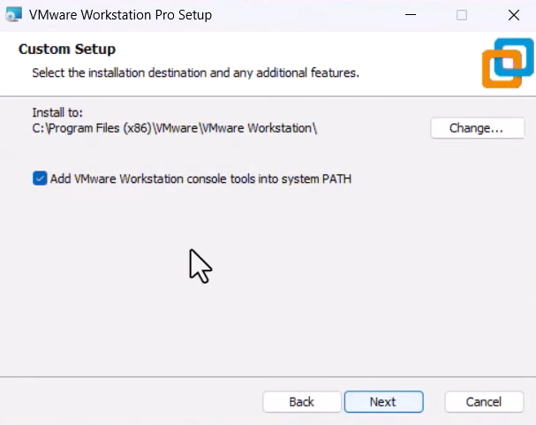

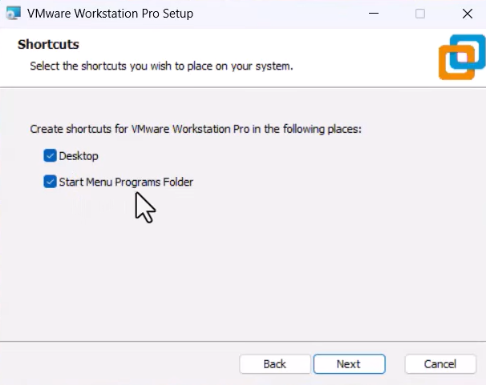

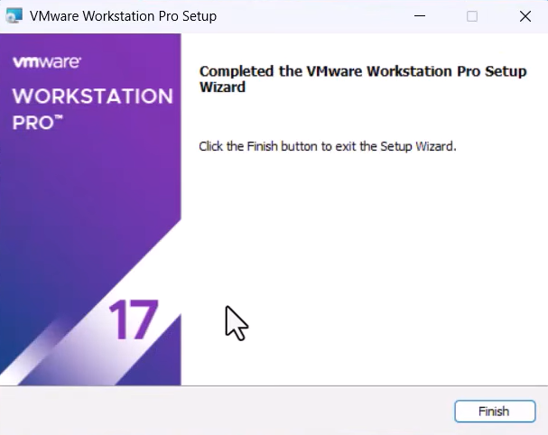

- The final App looks like this,

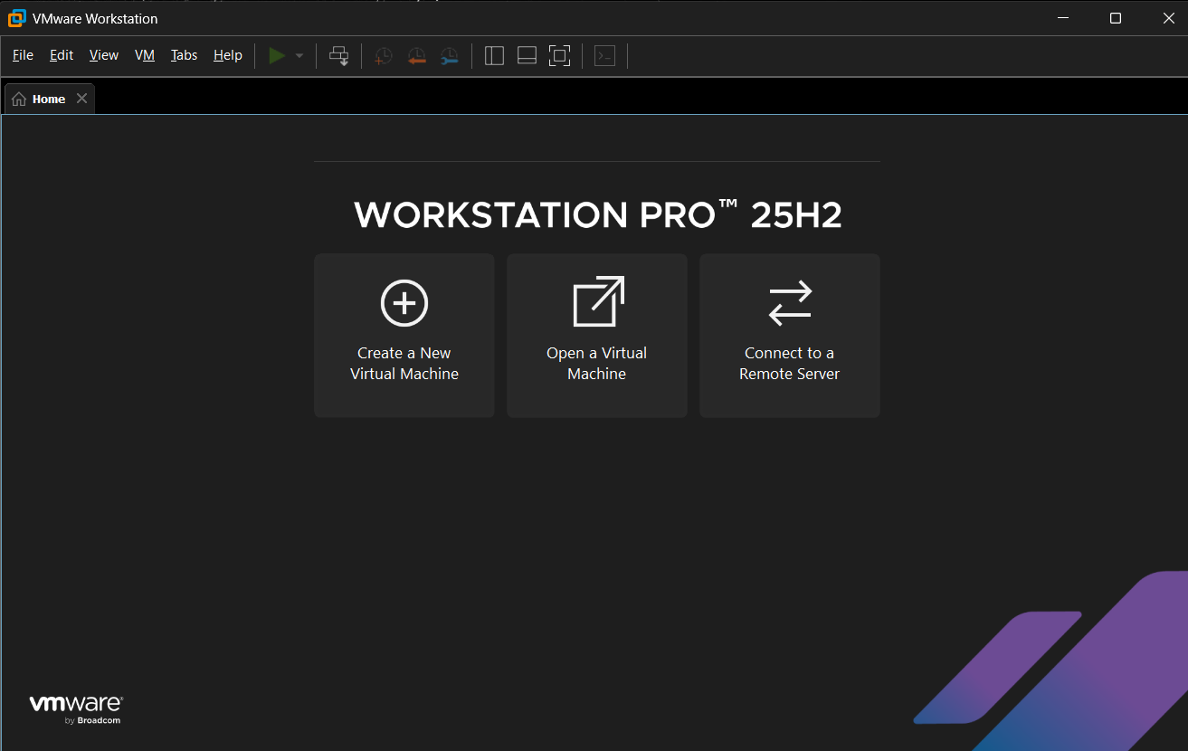

• Step 2 •
Step 2 : Install the zip file for Kali linux from Google.
This is what the extracted file looks like,

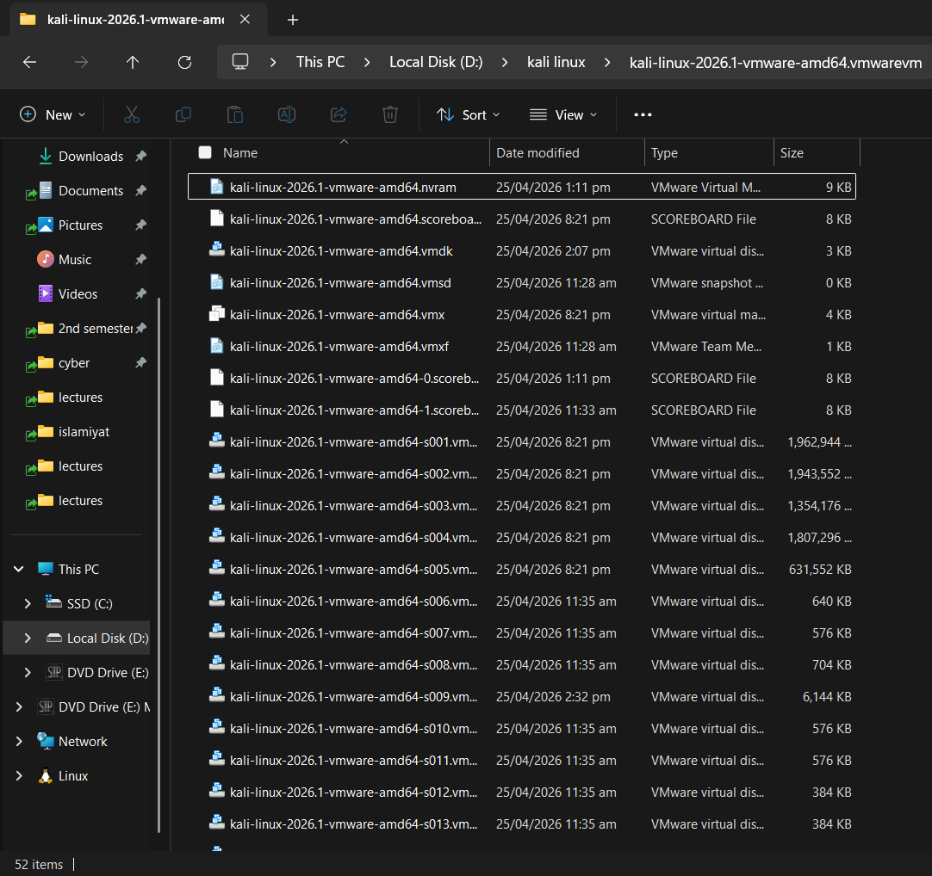

• Step 3 •
Step 3 : Extract the zip file and open it using VMware Workstation.

- Open VMware Workstation and select Open Virtual Machine,
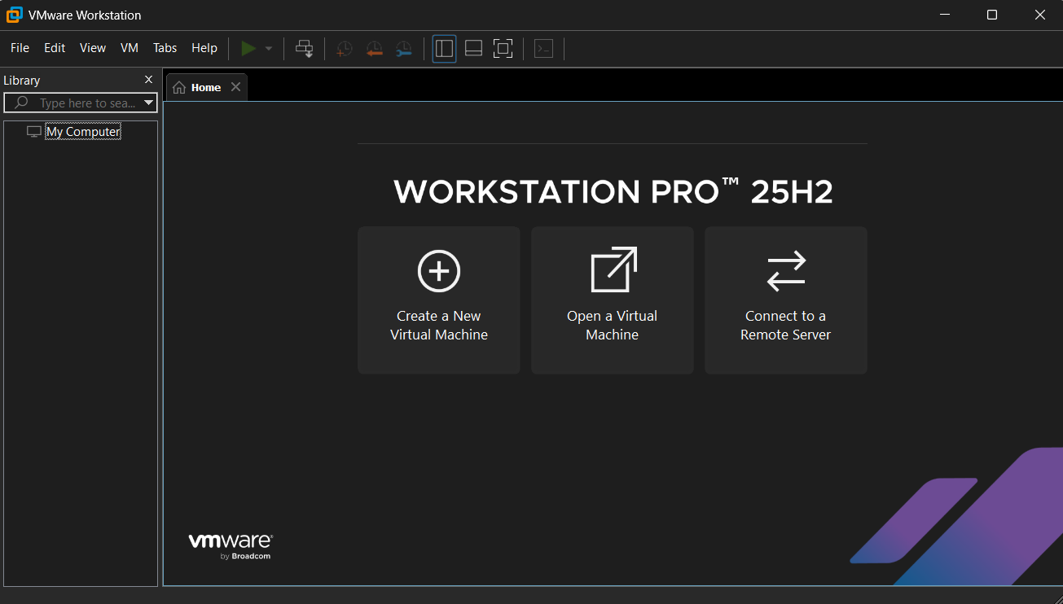

- Select the vmx file,
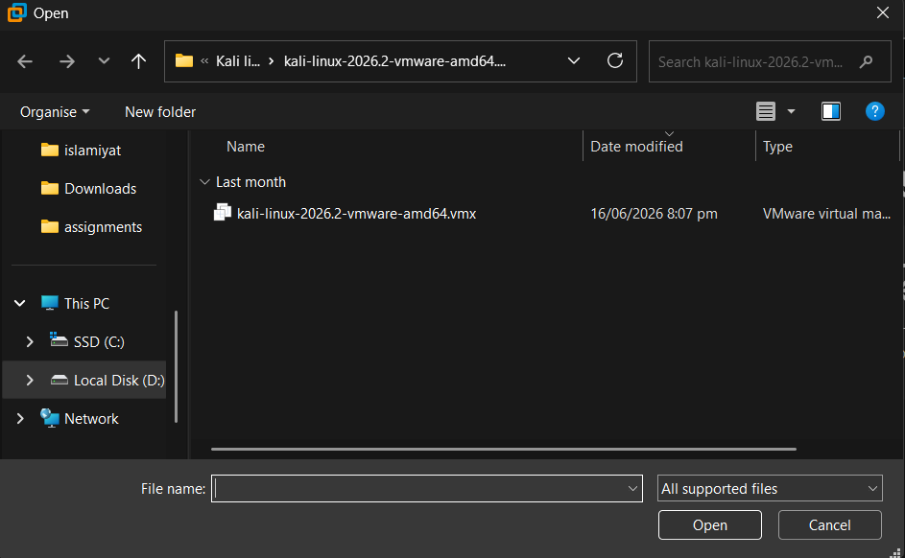

- You have successfully installed kali linux,
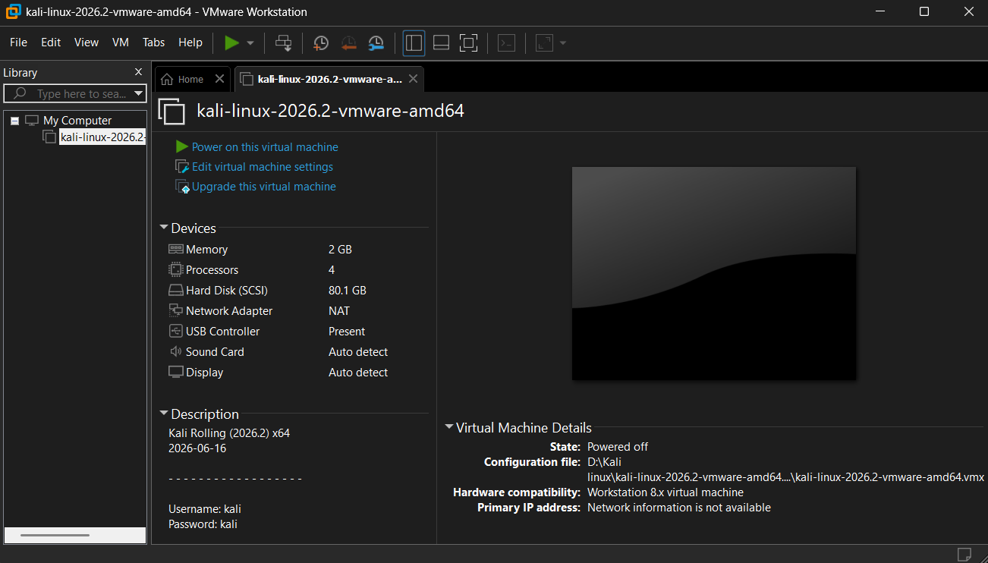

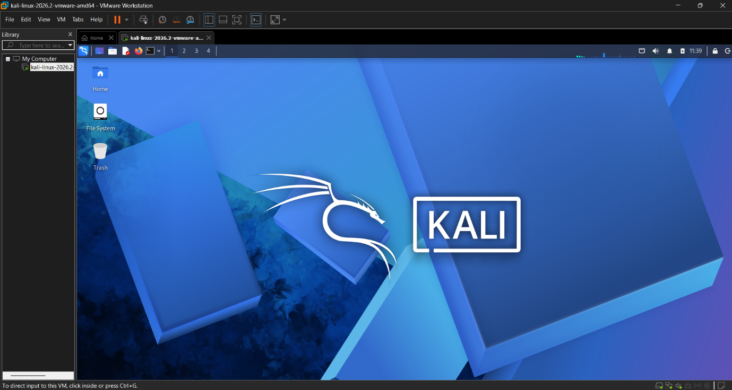
- Configure if you must and this is what the final screen looks like,

Assignment Conclusion:
In this assignment we installed Kali Linux as a guest Operating System using a Virtual Machine VMware Workstation. This increased and polished my ability to use and learn more about cybersecurity.

• The End •

